30.Ш. 2005 14:44
TRANSPARENCY INTERNATIONAL
263
NR.
S. 8/10

TRANSPARENCY
INTERNATIONAL

BULGARIA

TO
MR. VALENTIN CEROVSKI
MINISTER OF REGIONAL DEVELOPMENT
AND PUBLIC WORKS
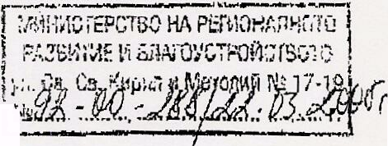

№ 42/22.03.05

DEAR MR. CEROVSKI,
I am writing to you in regard to the great number of publications in the national press containing alarming signals of possible violations of the contracting procedure of the Trakia motorway concession. The doubts caused by the lack of transparency on the concession procedure, as well as the high price of the Trakia motorway project, provoke the intervention of TI – Bulgaria. Transparency International is the biggest coalition worldwide dedicated to curbing corruption and with this purpose it unifies the efforts of NGOs, media and public institutions.
Since its founding in 1998, TI – Bulgaria has monitored a number of strategic privatization contracts, e. g. the BTC privatization and the granting of the second GSM license in Bulgaria. Due to our experience and the developed TI network of national and international experts, a number of Bulgarian governments have invited us to monitor public contracts of strategic importance.
With regard to this, I propose to you, on behalf of TI – Bulgaria and with the support of Transparency International, to let the organization monitor the Trakia concession procedure. The independent monitoring, as well as the public announcement of the basic parameters of the contracting bargain, will dispel possible doubts of non-transparency and will contribute to the effective public control over this significant project.
With a view to the successful constitution of TI – Bulgaria as an independent observer on the concession bargain, I appeal to you to let our experts examine closely the full documentation on the contract, and particularly, the concession contract.

I hope to have the opportunity to cooperate with you and I am expecting your fast reply.

Best regards,


Ognyan Minchev
Chairman of the Board of Directors
Transparency International - Bulgaria

